**LAB 8: IDA Pro**

**Course Name**: Malware Analysis and Reverse Engineering (IAM302)

**Student Name**: Nguyễn Trần Vinh – SE160258

**Instructor Name**: Mai Hoàng Đỉnh

**Lab Due Date**: 15/2/2023

**Purpose**

* You will practice using IDA Pro.
* You should already have the lab files

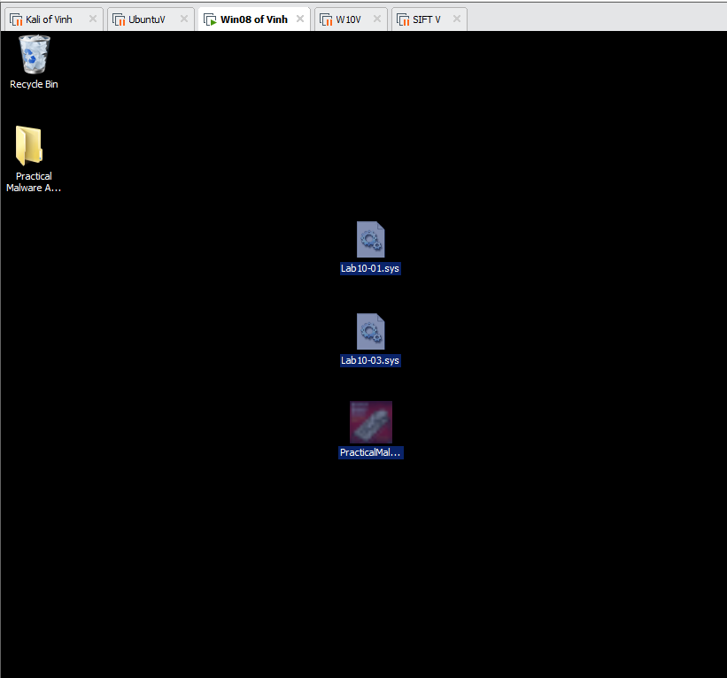

**What you need:**

* A Windows machine, real or virtual, such as the Windows 2008 Server VM we've been using
* The textbook: "Practical Malware Analysis"

**Downloading and Installing IDA Pro**

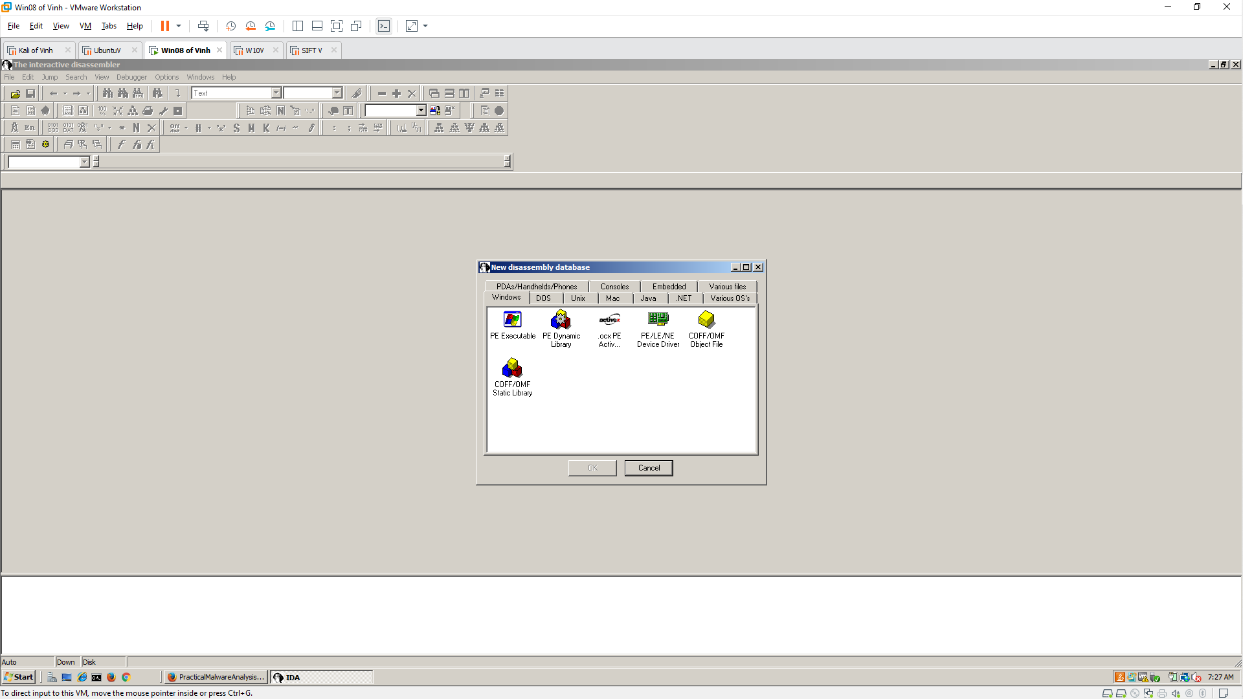

**Follow the Textbook**

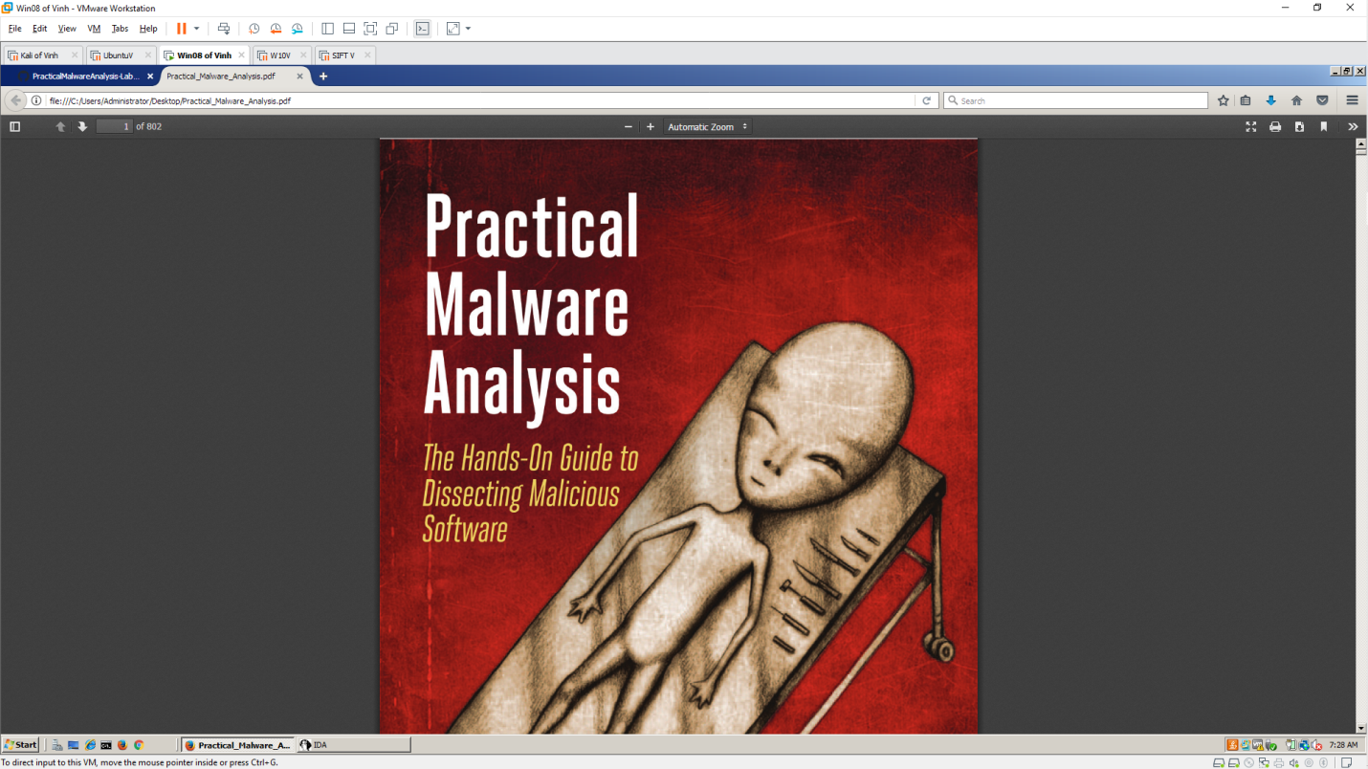

**Opening Lab05-01.dll in IDA Pro**

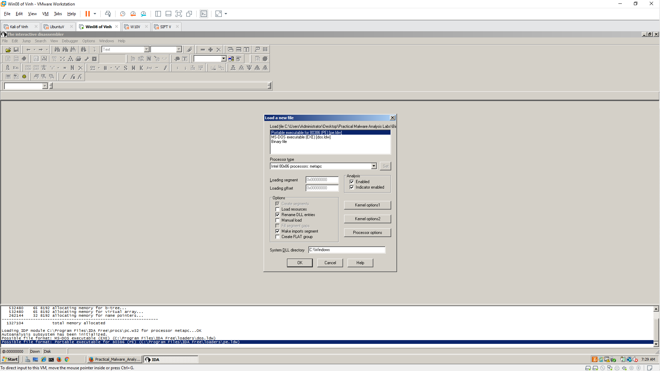

**Q1: Finding the Address of DLL Main**

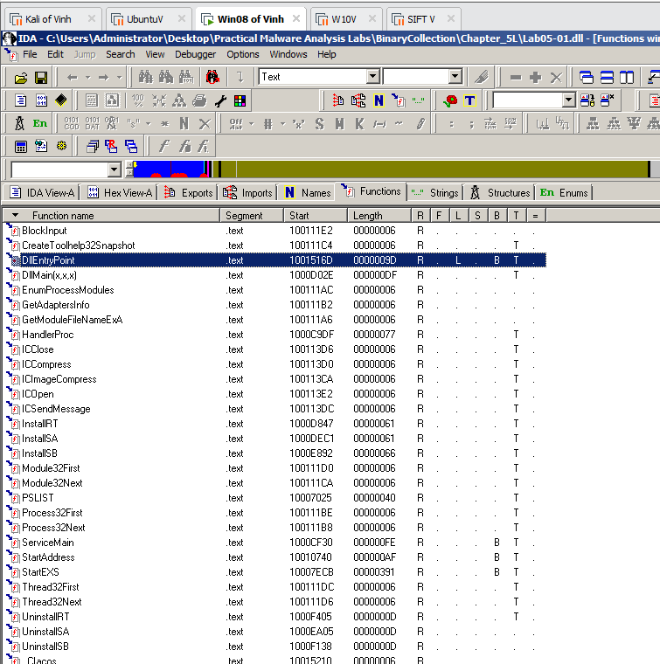

**Q2: Find the import for gethostbyname**

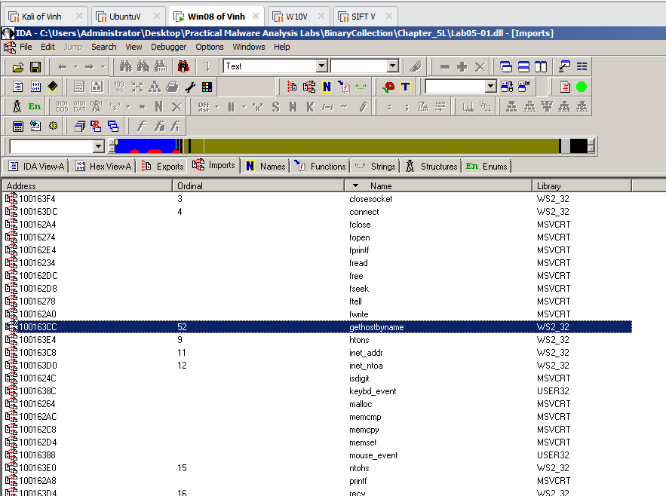

**Q3: How many functions call gethostbyname?**

* **9**

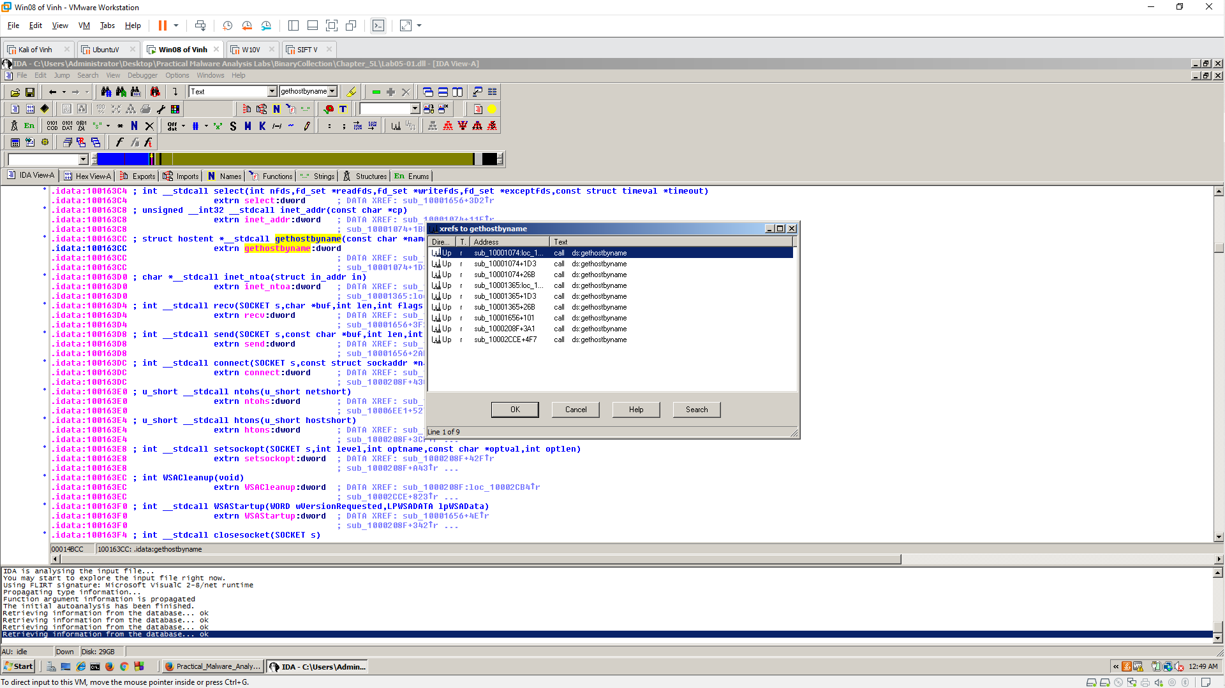

**Q4. Focusing on the call to gethostbyname located at 0x10001757, can you figure out which DNS request will be made?**

* **pics.praticalmalwareanalysis.com**

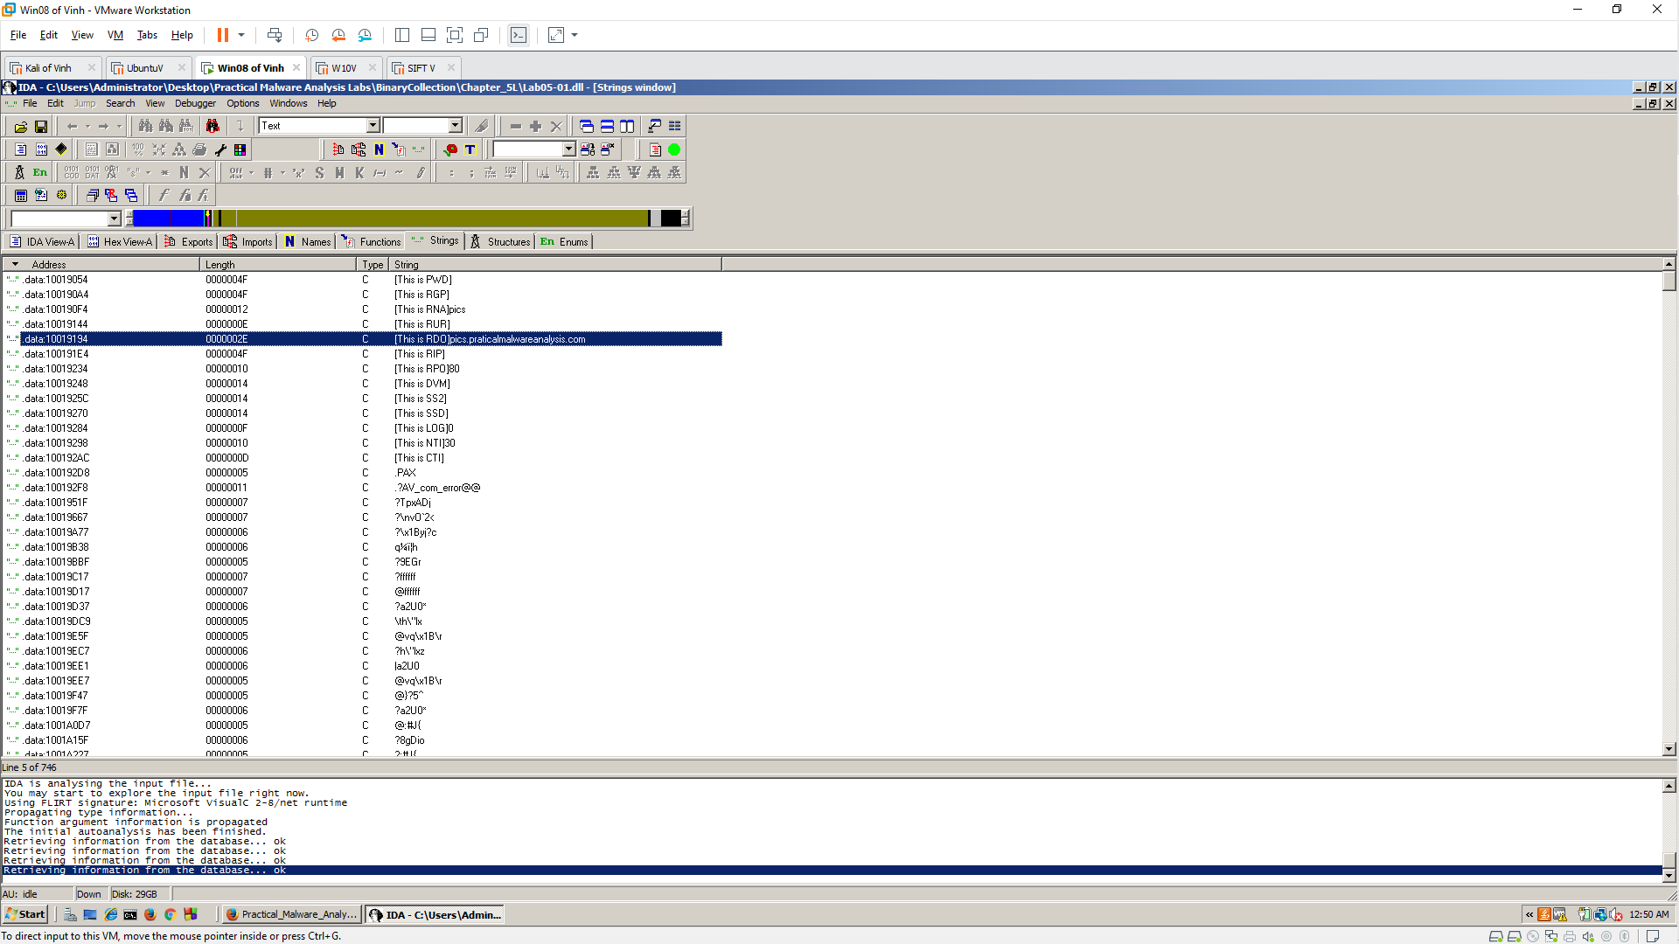

**Q5: Count Local Variables for the Subroutine at 0x10001656**

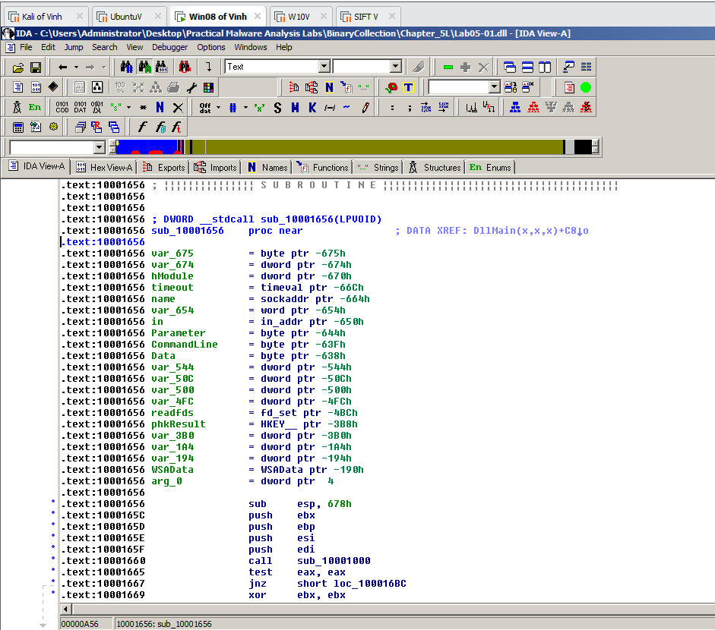

**Q6: How many parameters has IDA Pro recognized for the subroutine at 0x10001656?**

* **1**

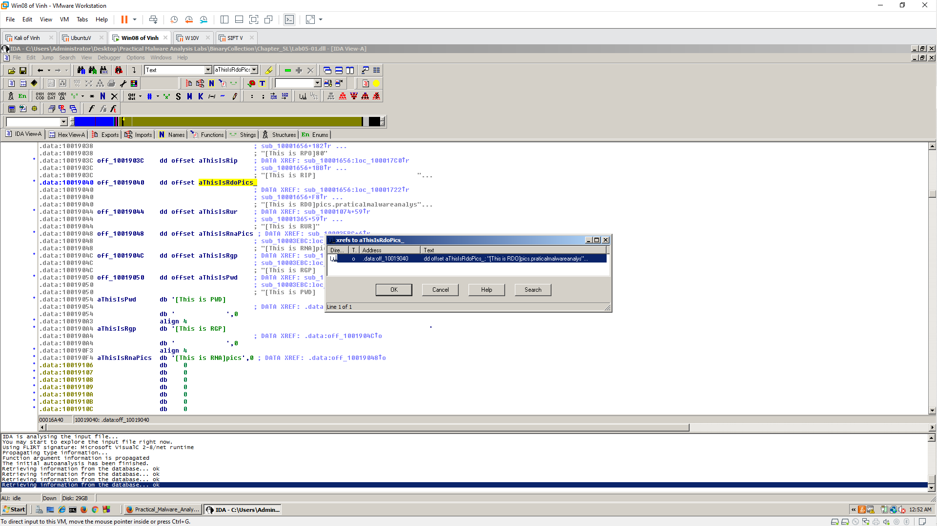

**Q7: Use the Strings window to locate the string \cmd.exe /c in the disassembly. Where is it located?**

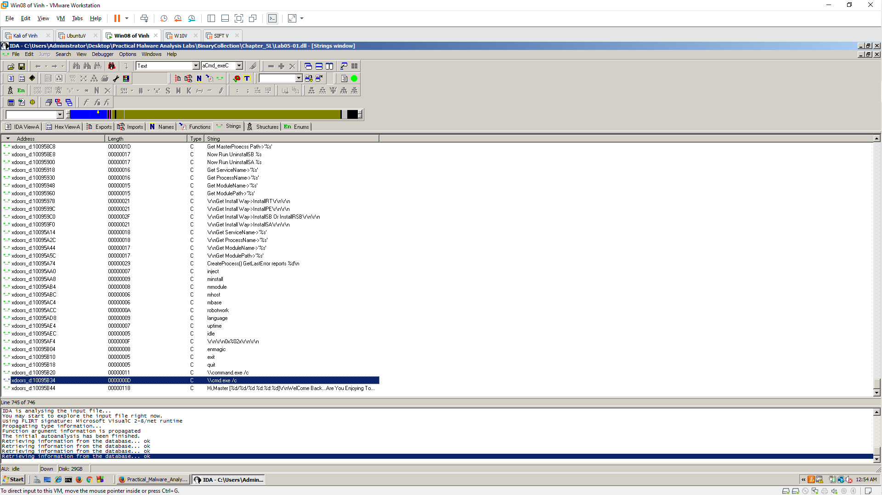

**Q8: Finding the Purpose of the Code that References \cmd.exe /c**

